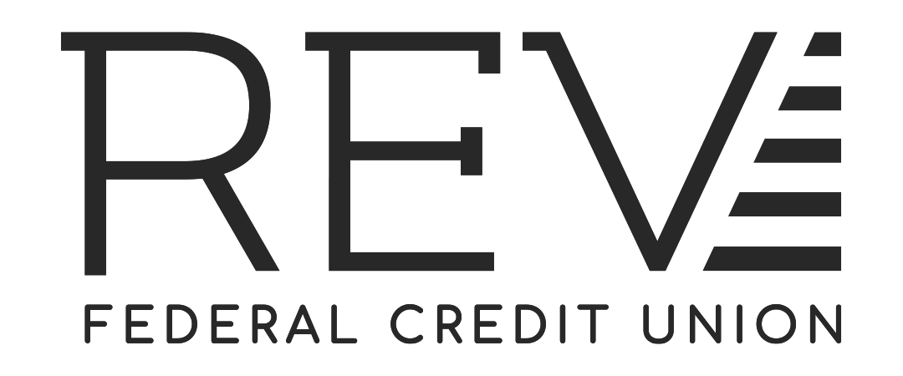
Truth in Lending Pre-Disclosure - Credit Cards
(REV Mastercard® for Business)
Interest Rates and Interest Charges
ANNUAL PERCENTAGE RATE (APR) for  Purchases and Cash Advance | 9.90% to 18.00%  This APR will vary with the market based on the Prime Rate* when you open your account, based on your creditworthiness and our underwriting standards.
Paying Interest | We will begin charging interest on the transaction date.
Minimum Interest Payment | None
For Credit Card Tips from the Consumer Financial Protection Bureau | To learn more about factors to consider when applying for or using a credit card, visit the website of the Consumer Financial Protection Bureau at http://www.consumerfinance.gov/learnmore
FEES:
Fees to Open or Maintain your Account  - Annual Fee: | $35.00 if card not used at least twelve times within a calendar year. Fee waived for the first 12 months.
Transaction Fees  - Balance Transfer:  - Cash Advance:  - Foreign Transaction: | 3% of the amount of each transfer  3% of the Cash Advance Amount for each Cash Advance  Up to 1% of each transaction in US dollars
Penalty Fees  - Late Payment:  - Return Payment: | $25.00  $35.00
Other Fees  - Research/Copy Fee:  - Pay by Phone Fee:  - Card Replacement Fee:  (includes Lost or Stolen) | $35.00 per hour; $6.00 per copy (statement or transaction receipt)  $15.00 – when paying over the phone with a live agent. No fee when paying by automated phone service.  $10.00
*ANNUAL PERCENTAGE RATE – Variable Rate: The Annual Percentage Rate (APR) may increase or decrease if the highest rate of interest identified as the “Prime Rate” in the 'Money Rates' column of the Wall Street Journal increases or decreases. The APR will be equal to the Prime Rate plus a margin of 6.65% to 14.75% based on your credit score. The interest rate may change quarterly on the first day of January, April, July, and October following a change in the Prime Rate. The APR for REV Mastercard® for Business will never be more than 18.00% or lower than 9.90% regardless of the applicable index and margin, unless specifically applicable laws and/or regulations require us to use a lower APR.

Minimum Payment: 2% of your balance or $15.00 whichever is greater. If the balance shown on your statement is $15.00 or less, you agree to pay that amount.

SEE PAGE TWO FOR MORE INFORMATION ABOUT YOUR ACCOUNT
How we will calculate Your Balance: We will use a method called “average daily balance (including new purchases).” See your account agreement for more details.

Billing Rights: Information on your rights to dispute transactions and how to exercise those rights is provided in your account agreement.

Security Interest: BY SIGNING AN APPLICATION, ACCEPTANCE OR AUTHORIZED USE OF ANY CREDIT CARDS, YOU GRANT AND PLEDGE A CONSENSUAL LIEN TO US ON ALL SHARES TO SECURE PAYMENT OF YOUR OBLIGATIONS ON THIS ACCOUNT AND A SECURITY INTEREST IN THE PROPERTY PURCHASED WITH YOUR CREDIT CARD. IN ADDITION, YOU ACKNOWLEDGE OUR STATUTORY LIEN RIGHTS UNDER THE FEDERAL CREDIT UNION ACT; YOU AGREE THAT SUCH A LIEN IS IMPRESSED AS OF THE DATE THAT THIS ACCOUNT IS OPENED; AND YOU AGREE THAT WE CAN APPLY THE SHARES PLEDGED AT THE TIME OF ANY DEFAULT ON THIS ACCOUNT WITHOUT FURTHER NOTICE. “Shares” for the purpose of your pledge to secure your obligations to the Credit Union means all deposits in any share savings, share draft, club, certificate, or other account(s) of the borrower or any guarantor, whether jointly or individually held -- regardless of contributions, that you have on deposit now or in the future.

The information about the costs of the card described in this application is accurate as of 05.21.2021. This information may have changed after that date. To find out what may have changed, call 800-845-5550 or 843- 832-2600, visit REVfcu.com, or write REV Federal Credit Union, P.O. Box 118000, Charleston SC 29423.

