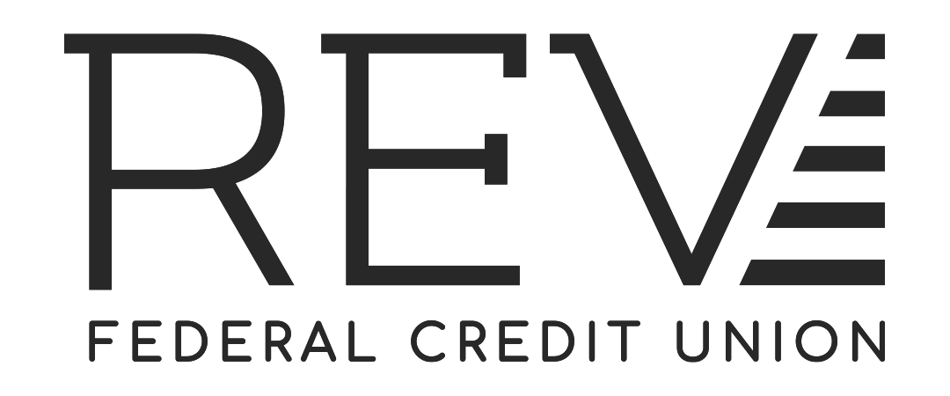
Truth in Lending Pre-Disclosure - Credit Cards
Interest Rates and Interest Charges
ANNUAL PERCENTAGE RATE (APR) for  Purchases, Balance Transfers and Cash Advance | 7.90% to 18.00%  This APR will vary with the market based on the Prime Rate* when you open your account, based on your creditworthiness and our underwriting standards.
Paying Interest | Your due date is at least 25-days after the close of each billing cycle. We will not charge you any interest on purchases if you pay your entire balance by the due date each month. We will begin charging interest on cash advances and balance transfers on the transaction date.
Minimum Interest Payment | None
For Credit Card Tips from the Consumer Financial Protection Bureau | To learn more about factors to consider when applying for or using a credit card, visit the website of the Consumer Financial Protection Bureau at http://www.consumerfinance.gov/learnmore

FEES:
Fees to Open or Maintain your Account  - Annual Fee: | NONE
Transaction Fees  - Balance Transfer:  - Cash Advance:  - Foreign Transaction: | 3% of the amount of each transfer  3% of the Cash Advance Amount for each Cash Advance  Up to 1% of each transaction in US dollars
Penalty Fees  - Late Payment:  - Return Payment: | $25.00  $35.00
Other Fees  - Research/Copy Fee:  - Pay by Phone Fee:  - Card Replacement Fee:  (includes Lost or Stolen) | $35.00 per hour; $6.00 per copy (statement or transaction receipt)  $15.00 –when paying over the phone with a live agent. No fee for paying by automated phone service.  $10.00
*ANNUAL PERCENTAGE RATE – Variable Rate: The Annual Percentage Rate (APR) may increase or decrease if the highest rate of interest identified as the “Prime Rate” in the 'Money Rates' column of the Wall Street Journal increases or decreases. The APR will be equal to the Prime Rate plus a margin of: 4.65% to 14.75% based on your credit score. The interest rate may change quarterly on the first day of January, April, July, and October following a change in the Prime Rate. The APR for any REV Mastercard® will never be more than 18.00% or lower than 9.90% for REV Mastercard® with Rewards, 17.90% for REV Secured Mastercard®, and 7.90% for REV Mastercard® with Low Rate regardless of the applicable index and margin, unless specifically applicable laws and/or regulations require us to use a lower APR.%.

Minimum Payment: 2% of your balance or $15.00 whichever is greater. If the balance shown on your statement is $15.00 or less, you agree to pay that amount.
SEE PAGE TWO FOR MORE INFORMATION ABOUT YOUR ACCOUNT

How we will calculate Your Balance: We will use a method called “average daily balance (including new purchases).” See your account agreement for more details.

Billing Rights: Information on your rights to dispute transactions and how to exercise those rights is provided in your account agreement.

Security Interest: The credit union will acquire a security interest in the property purchased with your credit card; and collateral securing other loans with us may also secure this account. Also, you are giving us a security interest in all individual and joint share(s) and/or deposit account(s) you have with us now or in the future.

Federal law provides important protections to members of the Armed Forces and their dependents relating to extensions of consumer credit. In general, the cost of consumer credit to a member of the Armed Forces and his or her dependent may not exceed an annual percentage rate of 36 percent. This rate must include, as applicable to the credit transaction or account: the costs associated with credit insurance premiums or debt protection fees; fees for ancillary products sold in connection with the credit transaction; any application fee or participation fee unless they are credit card fees which are bona fide and reasonable under the MLA. To receive this notice verbally, please call toll-free 1-800-845-5550 or 843-832-2600.

The information about the costs of the card described in this application is accurate as of 05.20.2021. This information may have changed after that date. To find out what may have changed, call 800-845-5550 or 843- 832-2600, visit REVfcu.com, or write REV Federal Credit Union, P.O. Box 118000, Charleston SC 29423.

